**Entregable 2**

**Diagrama de secuencia**

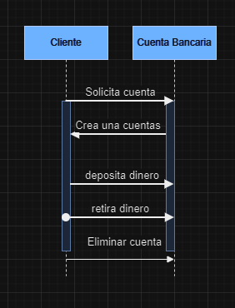

**Diagrama de Componentes**

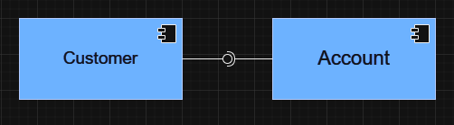

**Pruebas Postman**

**Customer**

**GET Customer**

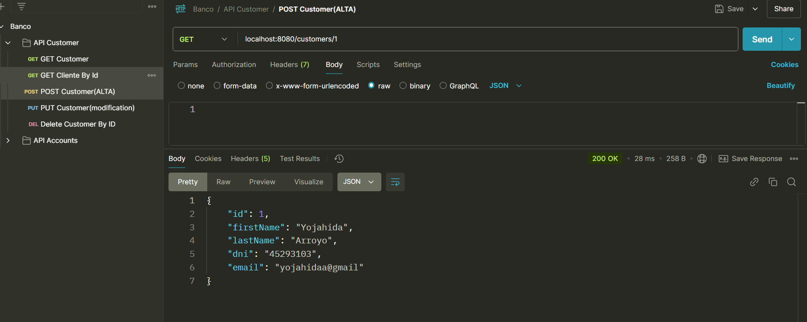

**GET Customer By Id**

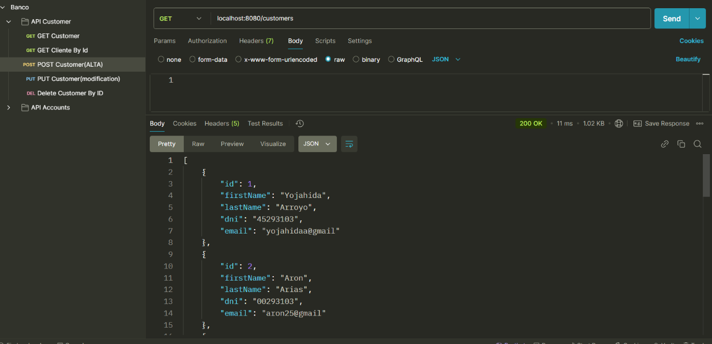

**POST Customer**

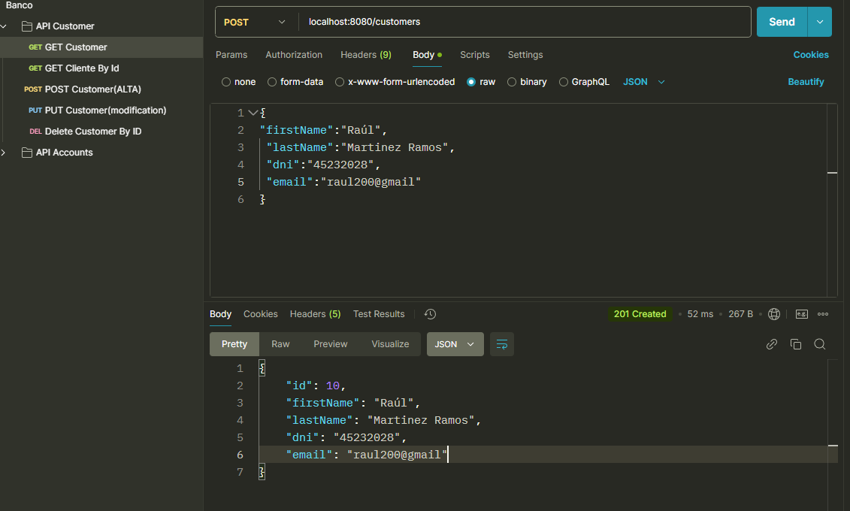

**Resultado MySQL**

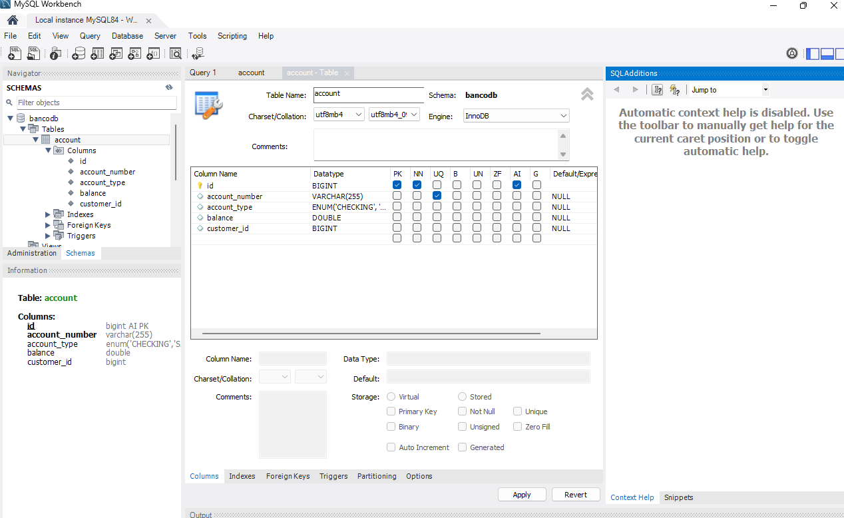

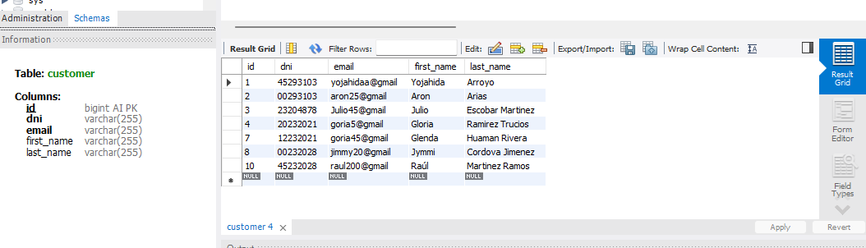

**PUT By Id**

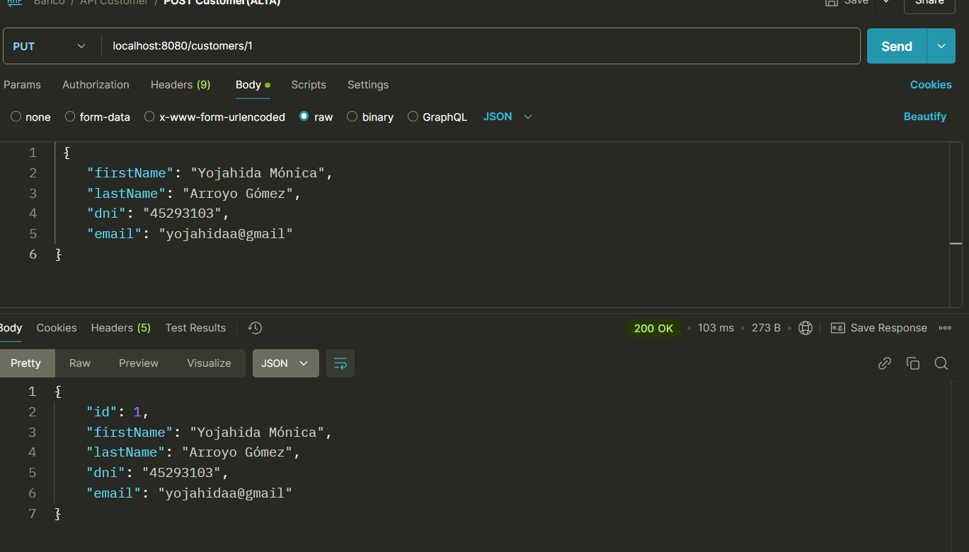

**Delete by ID**

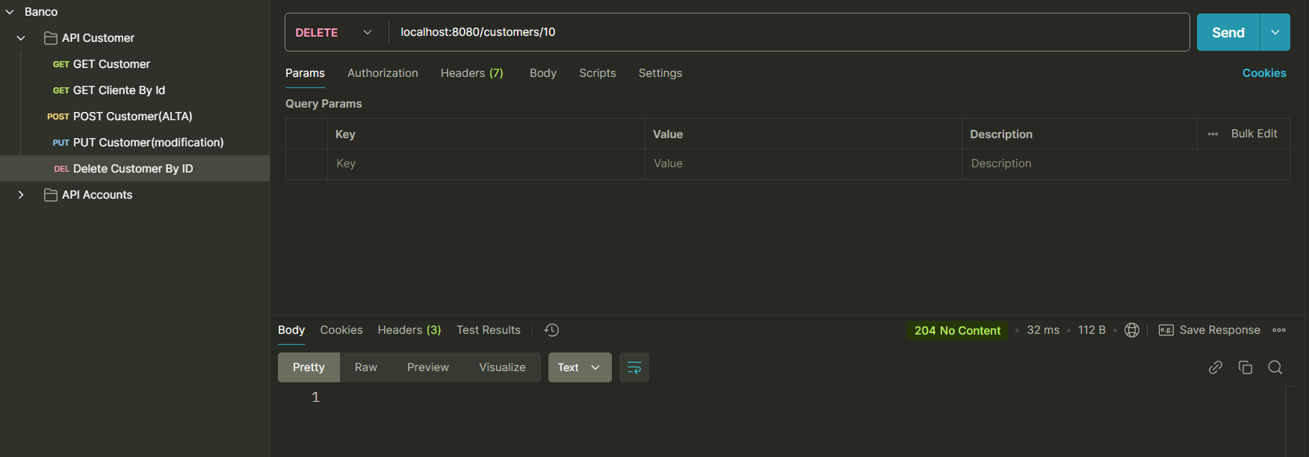

**Verificación en MySQL**

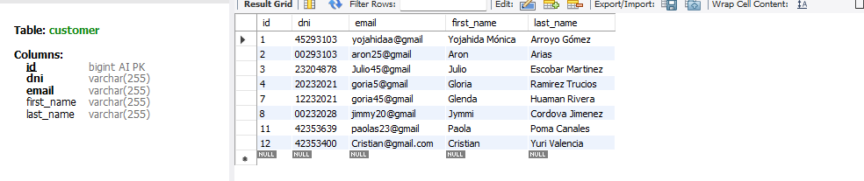

**Microservicio Account**

**POST Account**

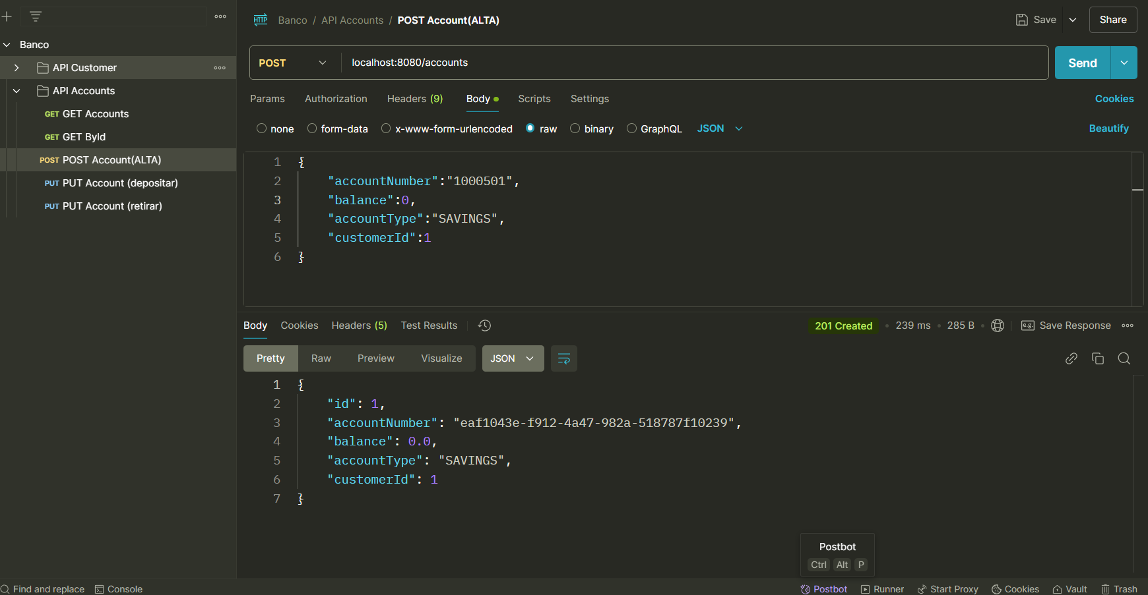

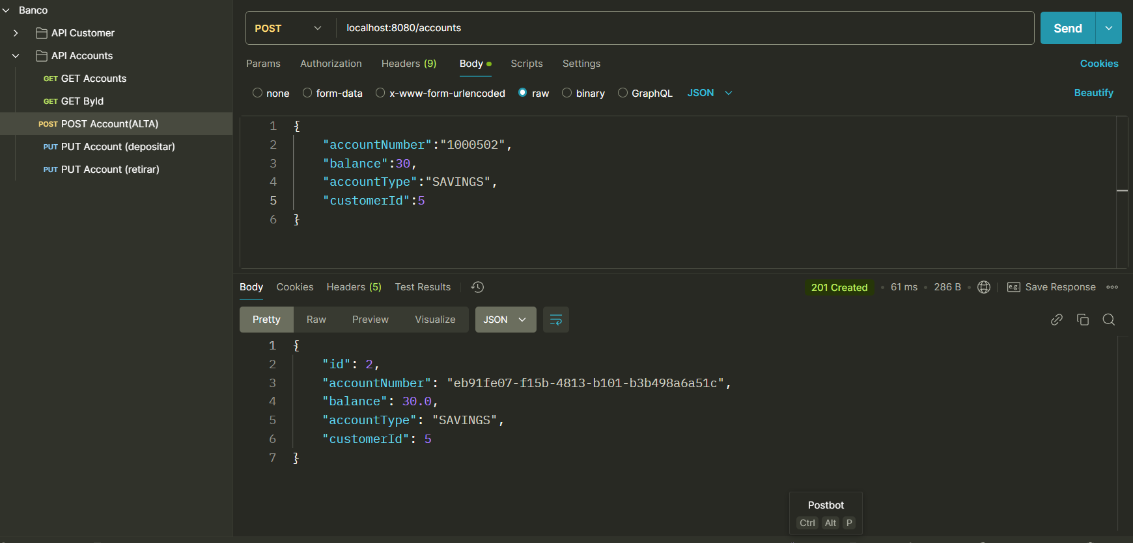

**Verificación MySQL**

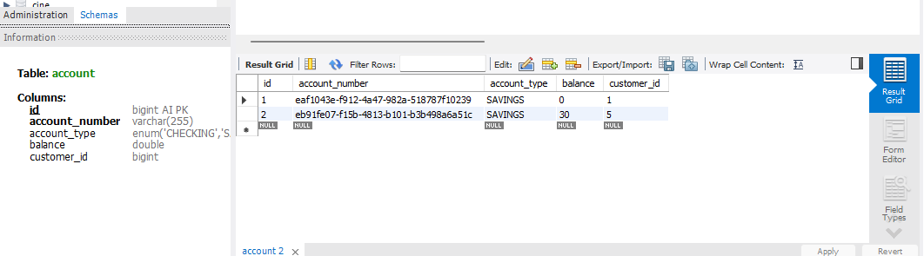

**GET Accounts**

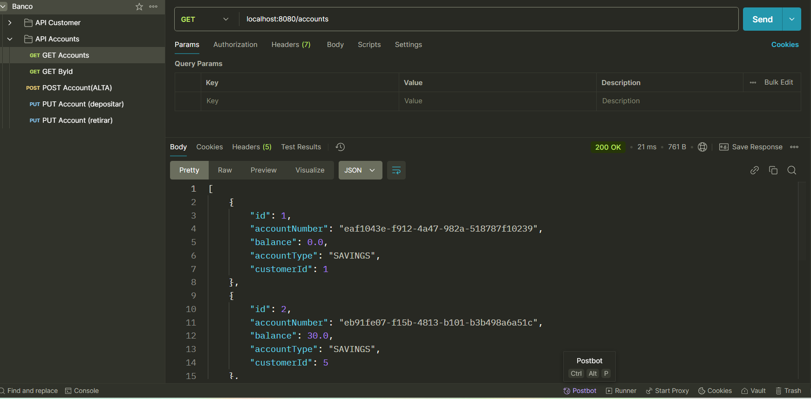

**GET By Id**

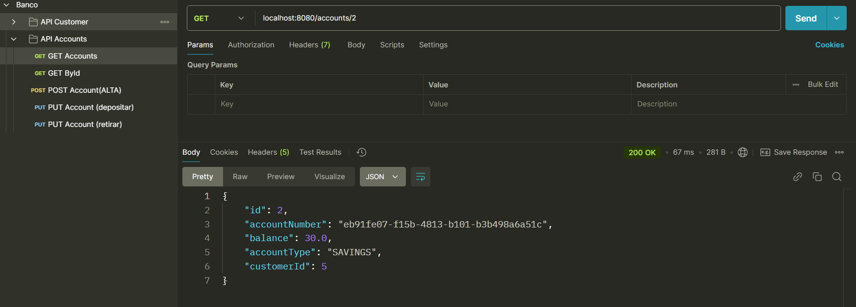

**PUT By Id (depositar)**

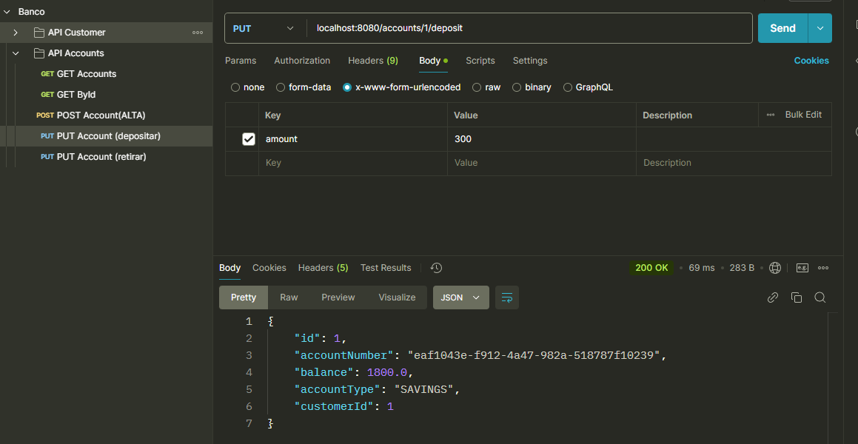

**PUT By Id (retirar)**

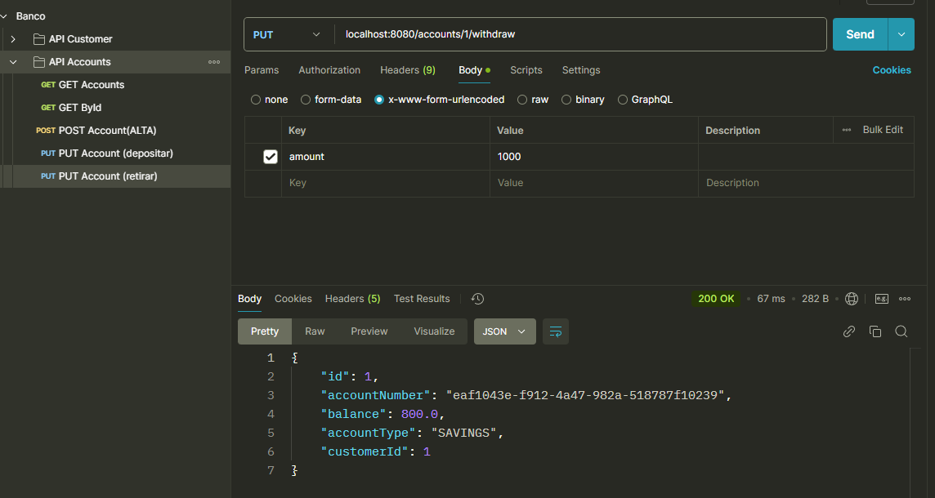

**DELETE Account**

